As disscussed, we need to amend and update the below based on the followings:
The updated UCL East dining gauge would feature:
• Three location buttons at the top (Pool Street Cafe, Marshgate Cafe, Marshgate Canteen)
• A circular clock-style gauge in the centre with color-coded sections:
◦ Green section (0-5 minutes)
◦ Amber section (5-10 minutes)
◦ Red section (10+ minutes)
• A moving needle pointing to the current wait time
• Below the gauge on the screen, details for the selected location through relevant button (eg : Pool Street Cafe):
◦ Today's special: Meal Deal(sandwich,Drink,Snakck) - £3.95
◦ Current wait time: 7 minutes (needle in amber zone)
• A QR code in the corner for accessing the digital twin with more information

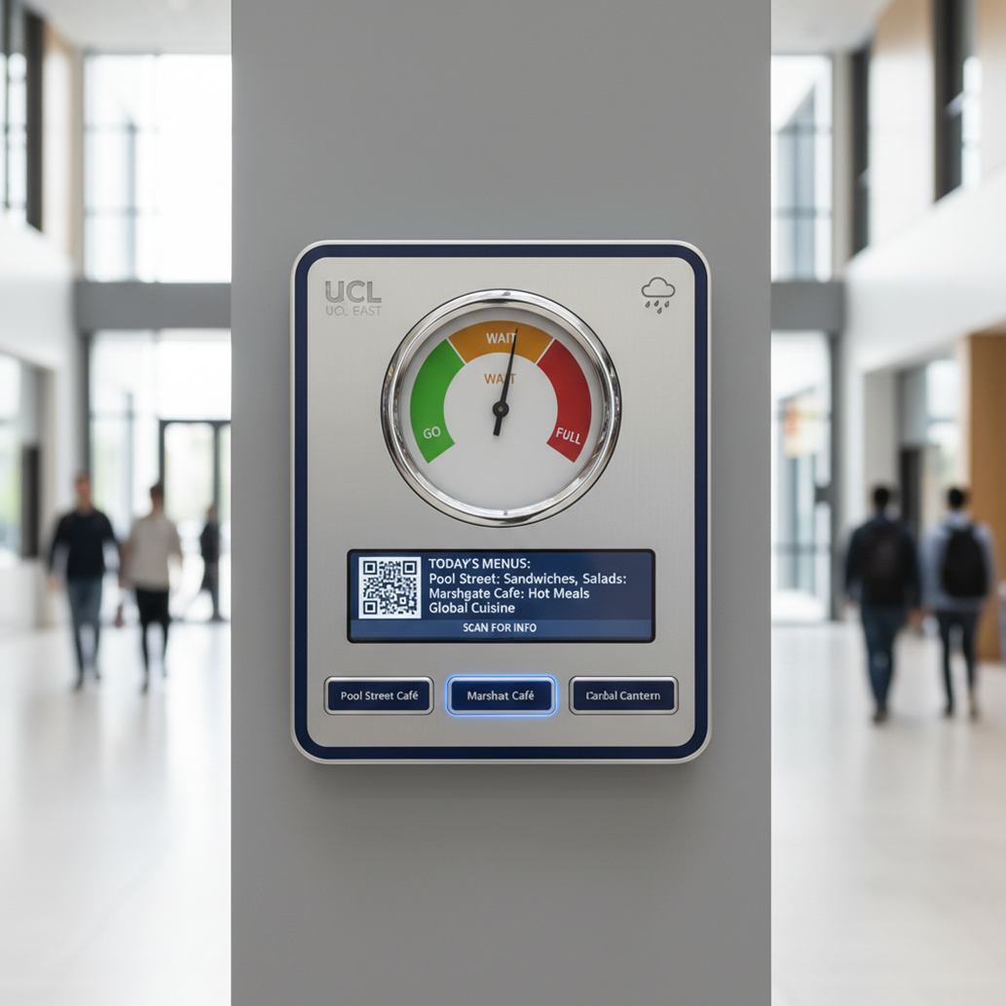

Green: (0-5 minutes) Low Wait.
Yellow/Amber: (5-10 minutes) Moderate Wait.
Red: (10+ minutes) Long Wait
- Relevant Menu Information
Special of the Day: Highlight the daily special or featured item. This encourages users to try new offerings and can help manage inventory.
Wait Times: Estimated time to receive an order can heavily influence a user's decision.
Price Range: A general indication of the affordability £££ helps users on a budget.
- Pool Street Café:
Coffee Specials: Highlight any unique or seasonal coffee drinks.
Pastries Available: Indicate the selection of fresh pastries.
Quick Bites: Sandwiches, salads, or other items that can be prepared quickly. Promote any bundled deals on snacks and drinks.
- Marshgate Café:
Vegan/Vegetarian Options: Clearly indicate the availability of plant-based choices.
Healthy Options: Highlight items known for their nutritional value (e.g., salads, smoothies).
Snack Deals: Promote any bundled deals on snacks and drinks.
- Marshgate Canteen:
Main Course Options: Display the main dishes available for lunch or dinner.
Dietary Information: Note any gluten-free, halal, or other dietary options.
Full Menu Link: Provide a quick link (via QR code or NFC tag) to the complete menu on the
digital twin.
Component | Functionality | Key Features
Physical Gauge | Decision-Making Aid | - Color-Coded EWT: Green (0-5 min), Amber (5-10 min), Red (10+ min).  - Needle Position: Shows estimated wait time.  - Menu Info: Rotating digital display/icons for top items.  - Augmented Twin Link: QR Code/ to load info template and the Digital Twin
Augmented Digital Twin | Context & Deep Dive | - Interactive Map: Real-time occupancy, queue lengths, available seating,EST for the other items on the menu  - Menu Details: Full menu, nutritional, allergen information, calories, price, stock level/availability  - Personalised Recommendations: Based on user preferences/historical data,user experience (multiple choice questions)  - Event Integration: Special events, promotions, timetables, footfall etc…

